Project Design Phase-II

Data Flow Diagram & User Stories

Date | 01-02-2026
Team ID | LTVIP2026TMIDS24918
Project Name | Visualizing Housing Market Trends: An Analysis of Sale Prices and Features using Tableau
Maximum Marks | 4 Marks

Data Flow Diagrams:
A Data Flow Diagram (DFD) is a traditional visual representation of the information flows within a system. A neat and clear DFD can depict the right amount of the system requirement graphically. It shows how data enters and leaves the system, what changes the information, and where data is stored.

- Data collected from POSOCO in CSV format.
- Cleaned and transformed, with calculated fields like Year and Lockdown.
- Visualizations built in Tableau using multiple worksheets.
- Users review the dashboard and may request changes.
- Final version archived after approval.

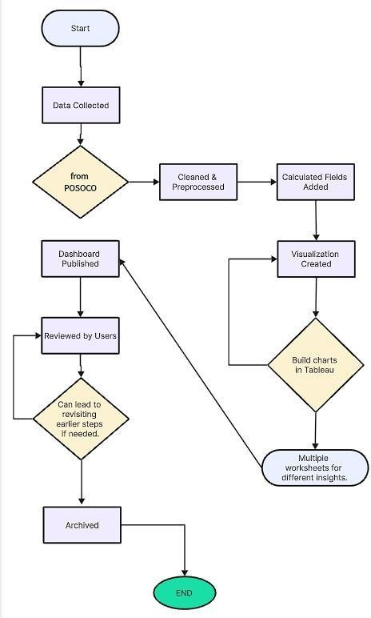

User Stories

User Type | Functional Requirement (Epic) | User Story Number | User Story / Task | Acceptance Criteria | Priority | Release
Real Estate Analyst | View Market Trends | USN-1 | As a user, I want to view housing price trends by year and renovation status so I can identify market patterns. | I can filter charts by  renovation year, house age, and sale price. | High | Sprint-1
Marketing Strategist | Compare Feature Trends | USN-2 | As a user, I want to compare house features (bedrooms, floors, bathrooms) and their  impact on pricing | I can view grouped bar and pie charts by feature  categories | Medium | Sprint-1
Executive / Manager | Export Reports | USN-3 | As a user, I want to export dashboards for reports and presentations. | I can download dashboard views as PDFs or images. | High | Sprint-2
Housing Data Analyst | Monitor Renovation Impact | USN-4 | As a user, I want to analyze how renovation age impacts price. | I can view bar and scatter plots showing renovation vs. pricing | High | Sprint-2
Developer | Connect Data | USN-5 | As a user, I want to automate data refresh from Excel or Google Sheets. | Data refreshes automatically or can be updated easily. | Medium | Sprint-2
Business Analyst | Compare Yearly Sales | USN-6 | As a user, I want to compare total sales by year. | I can view line or area charts showing yearly sales. | Low | Sprint-3

